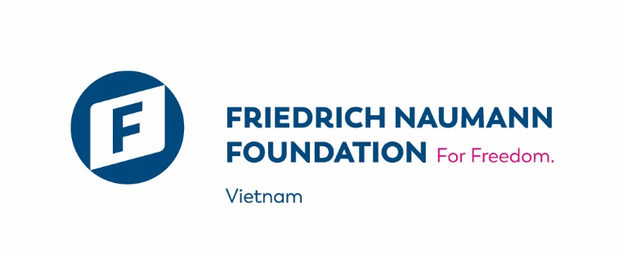
Friedrich Naumann Foundation for Freedom is a Germany's liberal NGO, working in Vietnam from 2012 with the mission of promoting the market economy in Vietnam through cooperation projects, exchanges and training programs. We are open for a 3-month internship (can be extended to 6 months) of graduated or under-graduated Vietnamese students since April 2021. Over the years, we have been fortunate to have highly driven interns help us at the foundation and support us in every part of our work on site.
What we offer:
- the possibility to work in a professional team in an international working environment;
- experience at a German foundation with offices in more than 60 countries in the world;
- experience in implementing ODA-funded projects;
- a real insight how we and our partners develop and support free market economy in Vietnam;
- a working plan adapted to your personal interests and professional development;
- a monthly allowance and a Certificate of Achievement;
- and joining events, seminars, workshops, coaching session, etc based on interest, strength and FNF’s works.
Our candidates ideally fulfill the following requirements:
- Demonstrated ability to communicate fluently in English, both written and verbal;
- Highly organized with meticulous attention to details;
- Ability to organize competing priorities;
- Be creative, proactive, ability to work in a team, and a penchant for project and communication activities;
- Have interest in European, Vietnamese politics and economics;
Successful candidates support our team in the following activities:
- Assist with administrative, financial, and logistic tasks for offices and project activities
- Assist project communication, e.g., support event organization, develop social media inputs etc
- Provide research support
- Perform interpretation and translation of documents if required
- Assist project team M&E: maintain database, project documentation, media clipping
- Other tasks as agreed with the supervisor
Working condition:
Successful candidate will work at Friedrich Naumann Foundation office in Vietnam (Address: 16/11 To Ngoc Van Street, Quang An, Tay Ho District, Hanoi)
Working time of 20 – 25 hours per week (ideally 5 hours per day), flexi-time.
How to apply:
Interested candidates please submit your application, including CV and Cover Letter combined in 1 pdf file, to Ms. Linh Bui (linh.bui@freiheit.org) before 23th March 2021.

